teamArchie – overseas sports coaching bursary
Cricket coaching for young refugees in Lebanon

Invitation to apply:

teamArchie is a charitable foundation set up in memory of Archie Lloyd. Archie adored sport, dabbled with music and theatre and was passionate about history and politics. Tragically he died in 2015, aged 18, whilst travelling with friends.

The charity sponsors projects which inspire and motivate young people to make the most of their lives. It aims to swing the pendulum of opportunity in favour of those who deserve a helping hand to be the best that they can be, but who lack the support they need to realise their ambitions.
www.teamarchie.org

teamArchie, in partnership with the Alsama Project in Lebanon and Youth Sport Trust International, is now offering two sports coaching bursaries for young people (aged 18 years+) to develop their cricket coaching skills and support young refugees living in camps in Beirut.

If you are passionate about coaching and cricket and helping young refugees, we look forward to hearing from you.

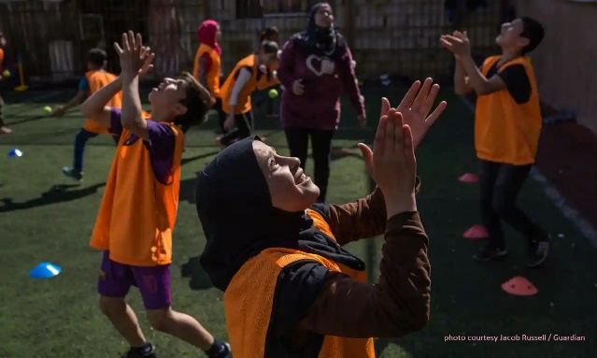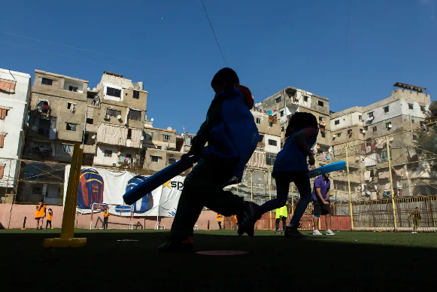

Role description:

Successful candidates will be expected to:
- Commit to living in Beirut, for a 3 month period (October to December or January to March or April to July)
- Undertake training by Youth Sport Trust International before travel
- Join the Alsama Cricket coaching team to provide regular training sessions to young refugees
- Support the Alsama Project in other ways as required of their interns
- Provide fortnightly progress reports to teamArchie
- Become an Ambassador for teamArchie

DBS checks, travel insurance, return flights, accommodation, subsistence and pre travel training will be covered for successful candidates.

Please complete the application form to apply for this bursary and submit by email to international@youthsporttrust.org by 31st August 2023.

About the charity partners:

Alsama Project
Alsama means ‘sky’ in Arabic. Established in January 2020, the Alsama Project is an NGO based in Lebanon which educates refugee children and empowers refugee women. Alsama sets up secondary education centres, sports hubs and social enterprises in areas of the Middle East affected by conflict. Projects are run for – and, in large part, run by – refugee communities. www.alsamaproject.com

Youth Sport Trust International
Youth Sport Trust International is a sport for development charity working across the globe, using the inspirational power of play, physical activity and sport to improve the life-chances of young people. Our key focus is on capacity building and sustainability, delivering bespoke training to upskill practitioners and young people. www.youthsporttrust.org

Application form

General information overview
First Name
Last Name
Date of birth
Phone number
Email address
Education to date | For example: A’Levels / BTEC, College, University
Please describe your experience of playing cricket and coaching children  (max 200 words) | For example: For how long? What age groups? Where you coach? Please provide a video of yourself playing cricket.

About you
Tell us about you
Why are you interested in cricket coaching young refugees in Lebanon?
(max 200 words)

What do you think would be the greatest benefit to you personally of this opportunity?
(max 200 words)

Why is coaching children important to you?
(max 200 words)

Please explain what you think you could bring to teamArchie as a mentor on your return.
(max 200 words)

Please explain why you believe you are deserving of this bursary award.
(max 200 words)

Anything else?
If you have any further comments or information that you think is relevant, please let us know.
(max 200 words)

Personal references
Please provide contact details for two people who can be contacted for a reference about your cricketing and coaching ability.
Name
Email address
Name
Email address

If you have any questions or any problems in submitting your application, please email international@youthsporttrust.org
